**CSS Architecture – ITCSS – Lab**

## About Page

Create a web page using **ITCSS** **architecture** like the following:

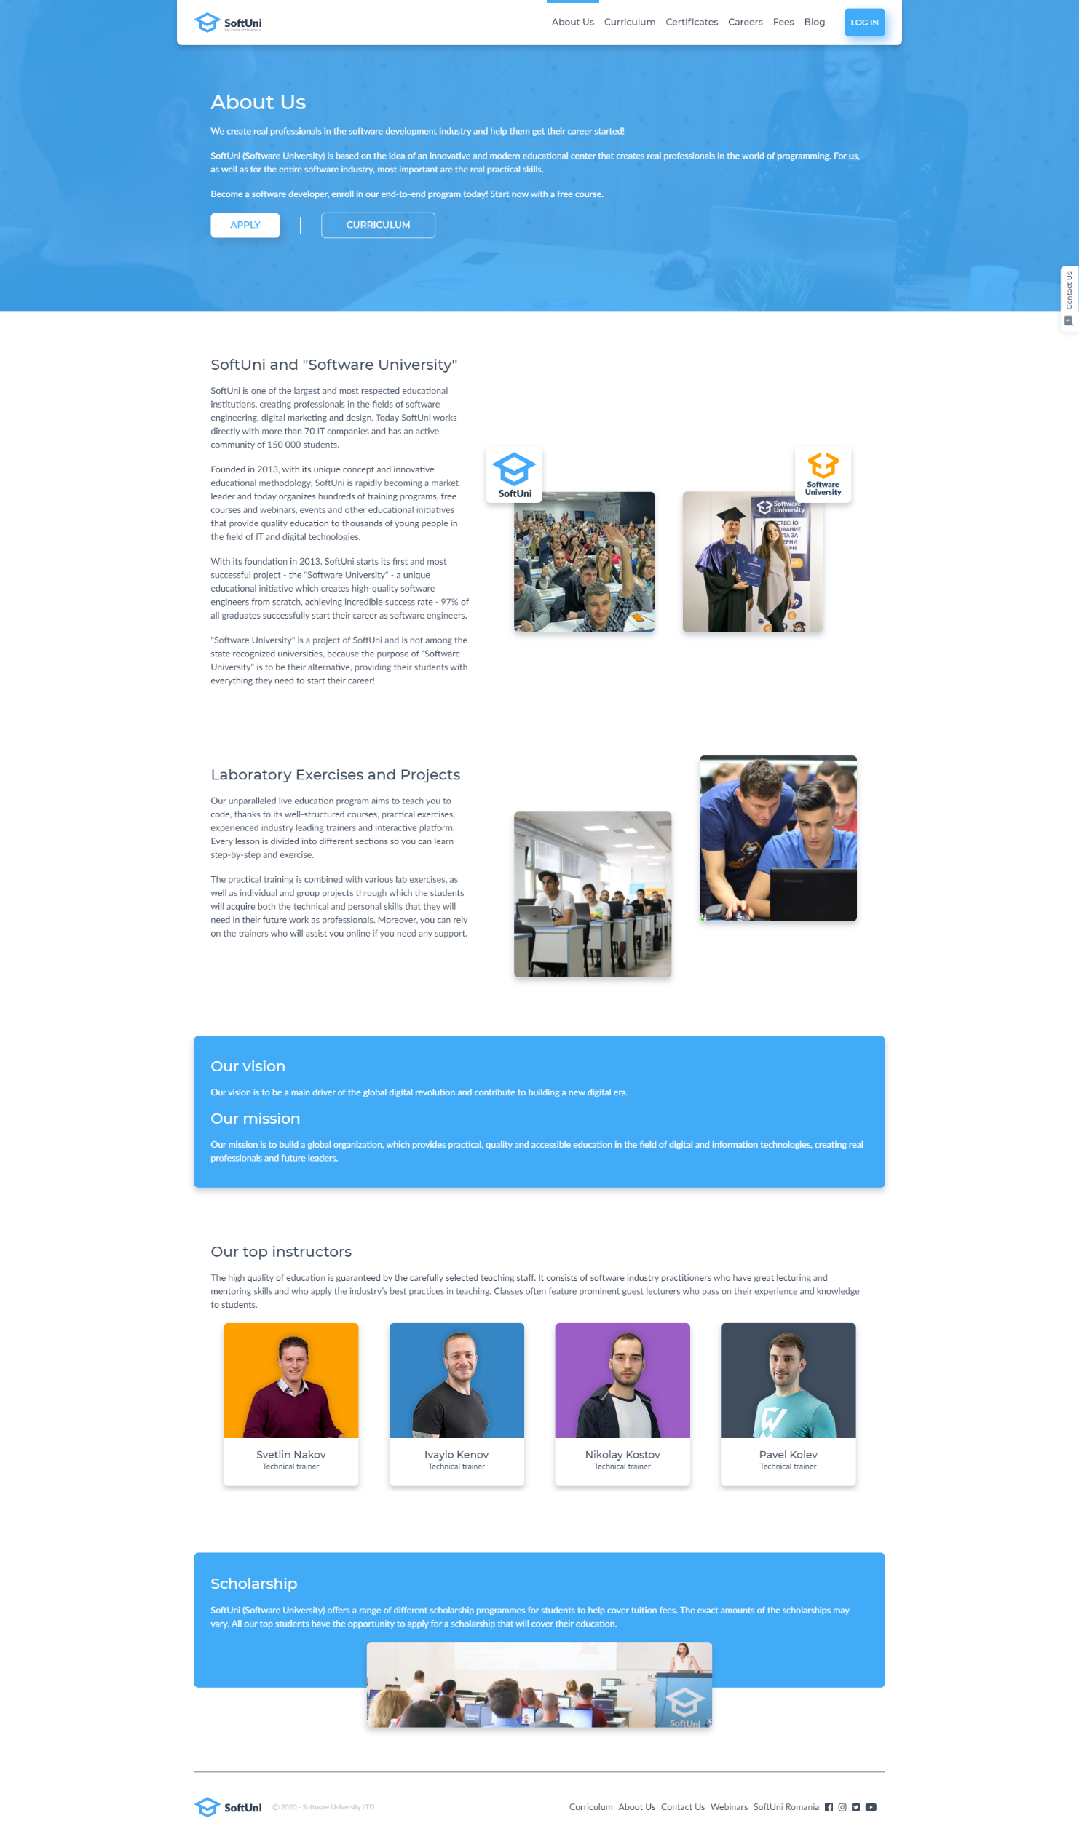

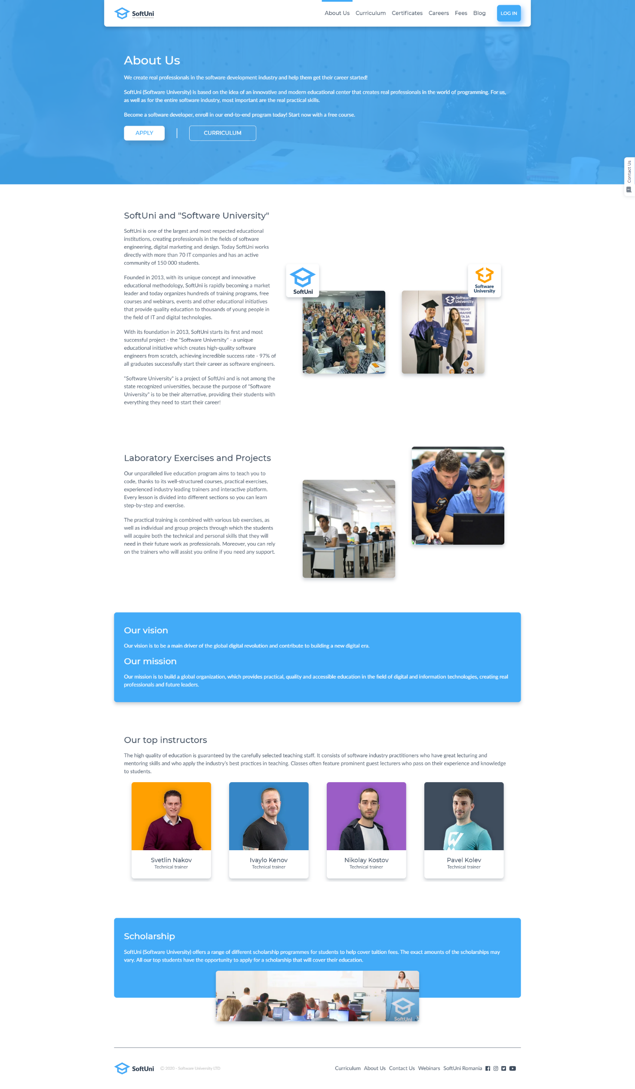

### Constraints

* Use font family "**Lato**" for the primary font
* Use font family "**Montserrat**" for the headings
* Divide your stylesheets using the **ITCSS** **architecture**
* Take your colors with [**color** **picker**](https://download.cnet.com/Just-Color-Picker/3000-2191_4-10428271.html)